I decided to store the customers in a hierarchical structure. At the top there are all customers responsible for a payment called primaryCustomers. Using the “ISA” connection I made two subtables that are children of primaryCustomers: one called eventCustomer and one called roomCustomer. For all three of these tables the primary key is a field called “cID” which stands for customer ID. For roomCustomer, I established a relationship between roomCustomer, dependentCustomer, and room, as a relationship table called books. The dependentCustomer table is a weak entity that engages in total participation with the relationship table (books). Its key is dependentName. The room table is used to store information about the rooms, and its primary key is the roomNumber. The books table uses information from roomCustomer and room to store information about room bookings. On the other side of the hierarchical structure there is a symmetrical flow. The event table, the eventDependents, and eventCustomer tables all engage with a relationship table called reserves. The event table stores information about events and is identified by eID (event ID). The eventDependents table stores information about the people who attend the event but do not pay. These three tables store information about each reservation between an eventCustomer and an event.

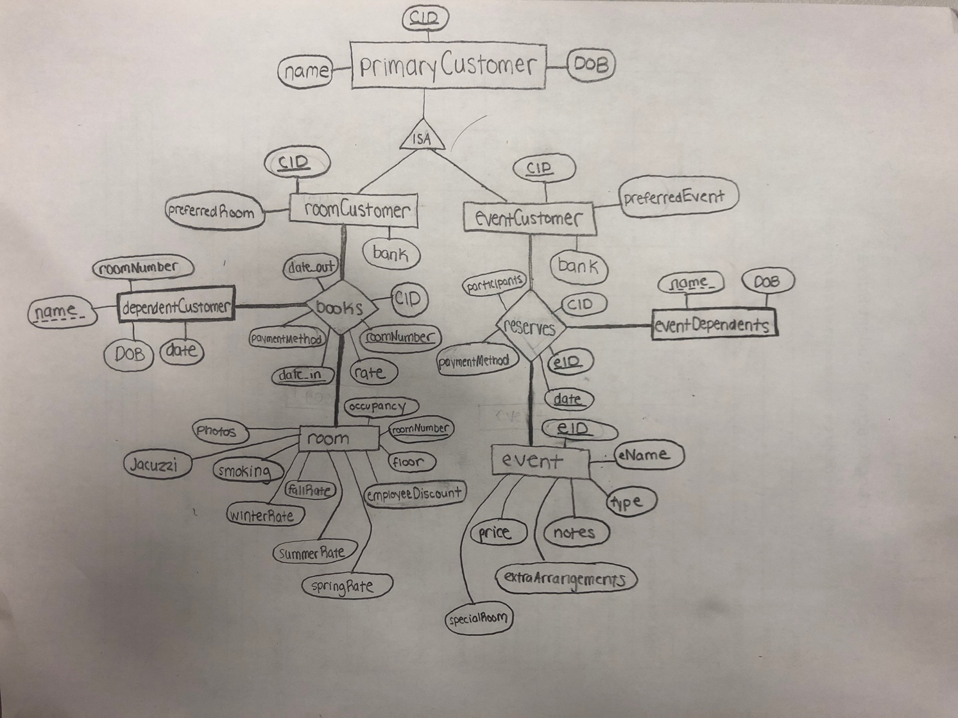

**CREATE DATABASE** hotel;  
  
**CREATE TABLE** primaryCustomer(  
 cID *INT* **NOT NULL**,  
 **name** *VARCHAR*(50) **NOT NULL**,  
 DOB *DATE*,  
 **PRIMARY KEY**(cID)  
 );  
  
**INSERT INTO** primaryCustomer(cID,**name**,DOB) **VALUES** (1, "John Abraham", '1987-02-23'),  
 (2, "Alex Smith", '1998-03-31'),  
 (3, "Mike Tirico", '1987-02-23'),  
 (4, "Dana Olive", '1987-02-23'),  
 (5, "Rebecca Martinez", '1997-08-07'),  
 (6, "Stanley Hudson", '1987-02-23'),  
 (7, "Meek Mill", '1987-02-23'),  
 (8, "Michael Jordan", '1987-02-23'),  
 (9, "Lebron James", '1987-02-23'),  
 (10, "Eric Plesko", '1987-02-23'),  
 (11, "Helicopter McFlurry", '1987-02-23'),  
 (12, "Alligator Miami", '1987-02-23');  
  
**CREATE TABLE** eventCustomer(  
 cID *INT* **NOT NULL**,  
 preferredEvent *VARCHAR*(25) **NOT NULL**,  
 bank *VARCHAR*(25) **NOT NULL**,  
 **PRIMARY KEY**(cID),  
 **FOREIGN KEY**(cID) **REFERENCES** primaryCustomer(cID));  
  
**INSERT INTO** eventCustomer (cID, preferredEvent, bank) **VALUES** (6, "Brunch Banquet", 'TD'),  
 (7, "Dinner Banquet", 'Chase'),  
 (8, "Bar Mitzvah", 'Mariners'),  
 (9, "Quinceanera", 'PNC'),  
 (10, "Brunch Banquet", 'Wells Fargo'),  
 (11, "Wedding Rehearsal", 'TD'),  
 (12, "Dinner Banquet", 'Chase');  
  
**CREATE TABLE** roomCustomer(  
 cID *INT* **NOT NULL**,  
 preferredRoom *VARCHAR*(25) **NOT NULL**,  
 bank *VARCHAR*(25) **NOT NULL**,  
 **PRIMARY KEY**(cID),  
 **FOREIGN KEY**(cID) **REFERENCES** primaryCustomer(cID));  
  
**INSERT INTO** roomCustomer (cID, preferredRoom, bank) **VALUES** (1, "Single", 'State Street'),  
 (2, "Double", 'Bank of America'),  
 (3, "Triple", 'JP Morgan'),  
 (4, "Quad", 'PNC'),  
 (5, "Queen", 'TD'),  
 (6, "Single", 'Chase'),  
 (7, "King", 'Wells Fargo');  
  
**CREATE TABLE** books(  
 roomNumber *INT* **NOT NULL**,  
 date_in *TIMESTAMP* **NOT NULL**,  
 date_out *TIMESTAMP*,  
 cID *INT* **NOT NULL**,  
 paymentMethod *VARCHAR*(12) **NOT NULL**,  
 rate DEC(7,2) **NOT NULL**,  
 **FOREIGN KEY** (roomNumber) **REFERENCES** room(roomNumber),  
 **FOREIGN KEY** (cID) **REFERENCES** primaryCustomer(cID),  
 **PRIMARY KEY** (roomNumber,date_in)  
);  
**INSERT INTO** books **VALUES** (212,'2019-03-31 4:30:07','2019-04-02 9:50:27',4,"Check",350),  
 (387,'2019-03-31 4:00:19','2019-04-03 10:12:27',7,"Cash",350),  
 (420,'2019-03-28 4:30:07','2019-04-02 10:50:22',3,"Credit",350),  
 (212,'2019-03-22 4:29:11','2019-03-29 8:21:33',2,"Check",350),  
 (510,'2019-02-28 4:30:07','2019-03-02 11:26:26',1,"Cash",350),  
 (919,'2019-02-14 4:30:07','2019-03-04 9:33:47',7,"Debit",350),  
 (660,'2019-02-12 4:30:07','2019-02-17 8:09:23',6,"Check",350),  
 (387,'2019-01-31 4:30:07','2019-02-02 5:11:45',5,"Credit",350),  
 (101,'2019-01-18 4:30:07','2019-01-19 6:48:15',2,"Check",350),  
 (660,'2019-03-26 4:30:07','2019-03-31 7:13:51',4,"Check",350),  
 (919,'2019-04-12 4:30:07','2019-04-20 6:56:34',3,"Cash",350),  
 (420,'2019-04-11 4:30:07','2019-04-15 7:12:44',1,"Cash",350),  
 (212,'2019-03-04 4:30:07','2019-03-12 9:41:51',3,"Credit",350),  
 (101,'2019-03-12 4:30:07','2019-03-17 5:34:11',4,"Debit",350),  
 (510,'2019-03-14 4:30:07','2019-03-25 6:31:43',5,"Check",350);  
  
  
  
  
  
**CREATE TABLE** room(  
 roomNumber *INT* **NOT NULL**,  
 occupancy *INT* **NOT NULL**,  
 floor *INT* **NOT NULL**,  
 employeeDiscount DEC(2,2) **NOT NULL**,  
 springRate DEC(7,2) **NOT NULL**,  
 fallRate DEC(7,2) **NOT NULL**,  
 summerRate DEC(7,2) **NOT NULL**,  
 winterRate DEC(7,2) **NOT NULL**,  
 smoking BIT **NOT NULL**,  
 jacuzzi BIT **NOT NULL**,  
 photos *VARCHAR*(80),  
 **PRIMARY KEY**(roomNumber)  
);  
**INSERT INTO** room **VALUES**(101,2,1,.85,300,250,310,200,0,0,"..."),  
(212,2,2,.90,350,300,380,240,0,1,"..."),  
(420,4,4,.75,290,250,305,190,1,0,"..."),  
(387,4,3,.70,234,200,260,210,1,0,"..."),  
(510,2,5,.82,330,300,400,200,0,0,"..."),  
(660,2,6,.85,305,260,315,200,0,1,"..."),  
(919,2,9,.97,1000,800,1200,750,0,1,"...");  
  
**CREATE TABLE** dependentCustomer(  
**name** *VARCHAR*(45) **NOT NULL**,  
roomNumber *INT* **NOT NULL**,  
dob *DATE* **NOT NULL**,  
**FOREIGN KEY** (roomNumber) **REFERENCES** room(roomNumber)  
);  
  
**INSERT INTO** dependentCustomer **VALUES** ("Jack Alabama", 212,'1985-04-28'),  
 ("Milly TheSavage", 919,'1985-12-31'),  
 ("Jack Alabama", 101,'1985-03-28'),  
 ("National Sapio", 420,'1985-03-19'),  
 ("HotDog Malibu", 387,'1985-03-11'),  
 ("Nick Ciambrone", 510,'1985-03-17'),  
 ("Paul Licini", 387,'1985-03-09'),  
 ("Scott Wills", 212,'1985-08-01'),  
 ("Yhago Silva", 101,'1985-03-02'),  
 ("Roxburio MatSlammer", 919,'1985-03-05'),  
 ("Starvation Runner", 387,'1985-09-25'),  
 ("Biceps McGee", 101,'1985-02-12'),  
 ("Jill Fun", 420,'1985-06-18'),  
 ("Roxanne East", 919,'1985-03-31');  
  
  
**CREATE TABLE** event(  
 eID *INT* **NOT NULL**,  
 eName *VARCHAR*(25) **NOT NULL**,  
 **type** *VARCHAR*(10) **NOT NULL**,  
 notes *VARCHAR*(100) **NOT NULL**,  
 extraArrangements *VARCHAR*(100) **NOT NULL**,  
 price DEC(8,2) **NOT NULL**,  
 specialRoom BIT **NOT NULL**,  
 **PRIMARY KEY**(eID)  
);  
  
**INSERT INTO** event **VALUES** (1, "Brunch Banquet", "Feast", "Eggs pancakes and more, big enough for 300 people", "Chefs", 1499.99,0),  
 (2, "Dinner Banquet", "Feast", "Steak Lobster and more, big enough for 300 people", "Chefs", 2499.99,0),  
 (3, "Quinceanera", "Party", "Spanish celebration for 15th birthday", "Mexican Music, Chefs", 1750.00,1),  
 (4, "Wedding Rehearsal", "Party", "Rehearse for the wedding", "Chefs, candles", 2650.00,1),  
 (5, "Bar Mitzvah", "Party", "Jewish celebration on becoming a man", "Chefs, Yamikahs, Chair", 1250.00,1),  
 (6, "Prom", "Party", "High School Prom, lots of fun", "DJ, poster", 2000.00,0);  
  
**CREATE TABLE** eventDependents(  
 **name** *VARCHAR*(40) **NOT NULL**,  
 eID *INT* **NOT NULL**,  
 DOB *DATE* **NOT NULL**,  
 **PRIMARY KEY**(**name**)  
);  
**INSERT INTO** eventDependents **VALUES** ('John Lewinsky', 1,'1988-09-19'),  
 ('PJ Tucker', 2,'1988-09-19'),  
 ('Rip Panorama', 3,'1988-09-19'),  
 ('Pterodactyl Jones', 4,'1988-09-19'),  
 ('Lasquarius VonHampton', 5,'1988-09-19'),  
 ('Roqualiacous Simple', 6,'1988-09-19'),  
 ('Instario Sabadaba', 1,'1988-09-19'),  
 ('Mike Allen', 2,'1988-09-19'),  
 ('JarHead McBeastly', 6,'1988-09-19'),  
 ('Probation Godzilla', 5,'1988-09-19'),  
 ('MaryJane Johnson', 3,'1988-09-19'),  
 ('Attack Milloy', 4,'1988-09-19'),  
 ('Rachel Moore', 1,'1988-09-19');  
  
  
**CREATE TABLE** reserves(  
 eID *INTEGER* **NOT NULL**,  
 *date TIMESTAMP* **NOT NULL**,  
 cID *INT* **NOT NULL**,  
 participants *INT* **NOT NULL**,  
 paymentMethod *VARCHAR*(10),  
 **PRIMARY KEY**(eID, *date*),  
 **FOREIGN KEY** (cID) **REFERENCES** primaryCustomer(cID),  
 **FOREIGN KEY** (eID) **REFERENCES** event(eID)  
);  
  
**INSERT INTO** reserves **VALUES** (2,'2019-02-01 12:11', 10, 280, "Check"),  
 (1,'2019-03-30 12:00', 7, 280, "Check"),  
 (2,'2019-03-13 12:00', 8, 280, "Credit"),  
 (3,'2019-03-11 12:00', 9, 280, "Check"),  
 (3,'2019-02-02 12:00', 10, 280, "Check"),  
 (3,'2019-01-19 12:00', 10, 280, "Check"),  
 (4,'2019-04-24 12:00', 12, 280, "Credit"),  
 (6,'2019-04-25 12:00', 11, 280, "Check"),  
 (4,'2019-05-01 12:00', 10, 280, "Check"),  
 (5,'2019-04-30 12:00', 9, 280, "Debit"),  
 (1,'2019-03-06 12:00', 6, 280, "Check");

**SELECT DISTINCT** r.cID  
**FROM** reserves r  
**GROUP BY** r.cID  
**HAVING** count(r.cID)= (**SELECT DISTINCT** MAX(r.maxRes)  
 **FROM** (**SELECT DISTINCT** cID, COUNT(cID) **AS** maxRes  
 **FROM** reserves  
 **WHERE** *date* **BETWEEN** '2019-01-01 00:01:00' **AND** '2019-12-31 23:59:59'  
 **GROUP BY** cID) r);

This Query selects the customerID column from the reserves relation, grouped by cID having count(r.cID) = a nested relation that finds the maximum value from the count(cID) coulumn in that same relation:

The result is a table with one row: the customer ID of the customer who booked the most rooms:

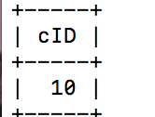

All the relations before adding anything via an HTML file linked to a python file:

primaryCustomer:

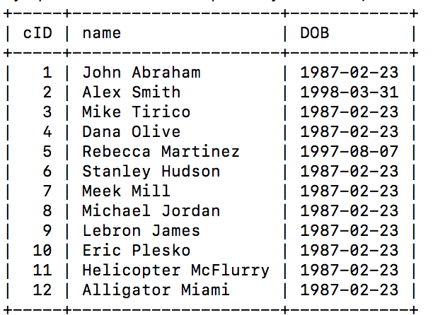

roomCustomer:

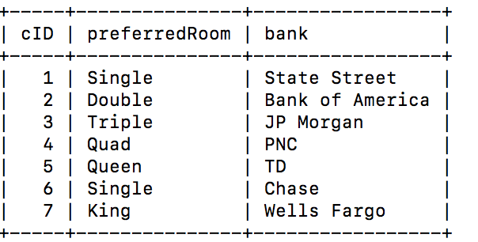

eventCustomer:

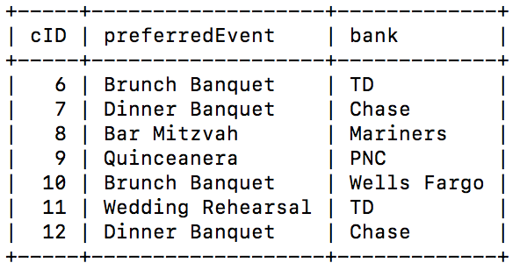

rooms:

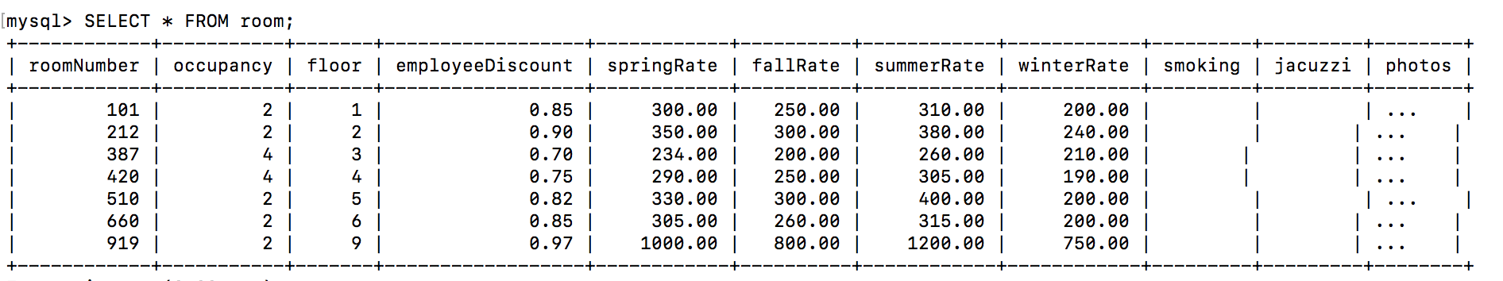

event:

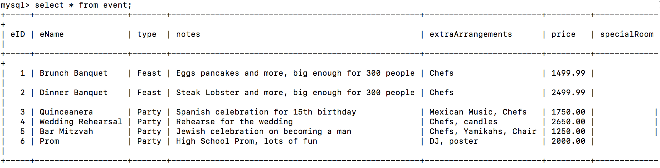

books:

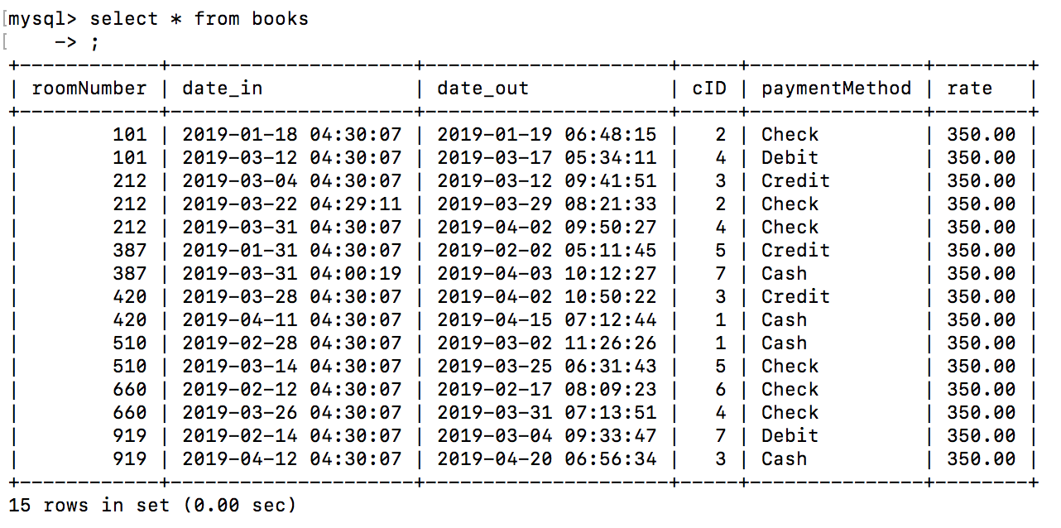

reserves:

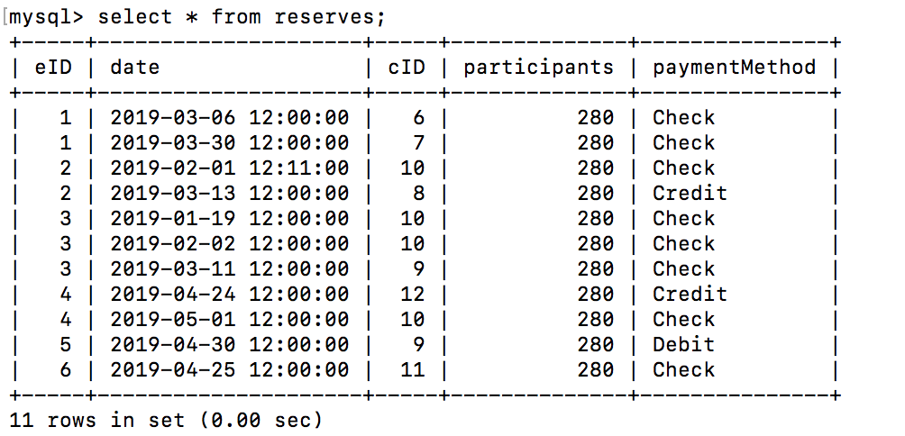

eventDependents:



roomDependents:

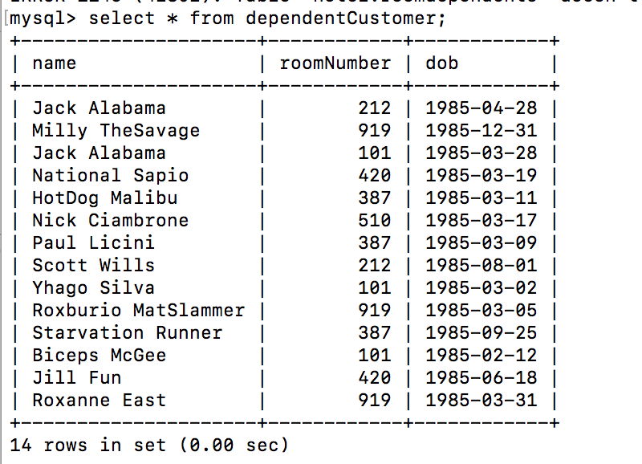

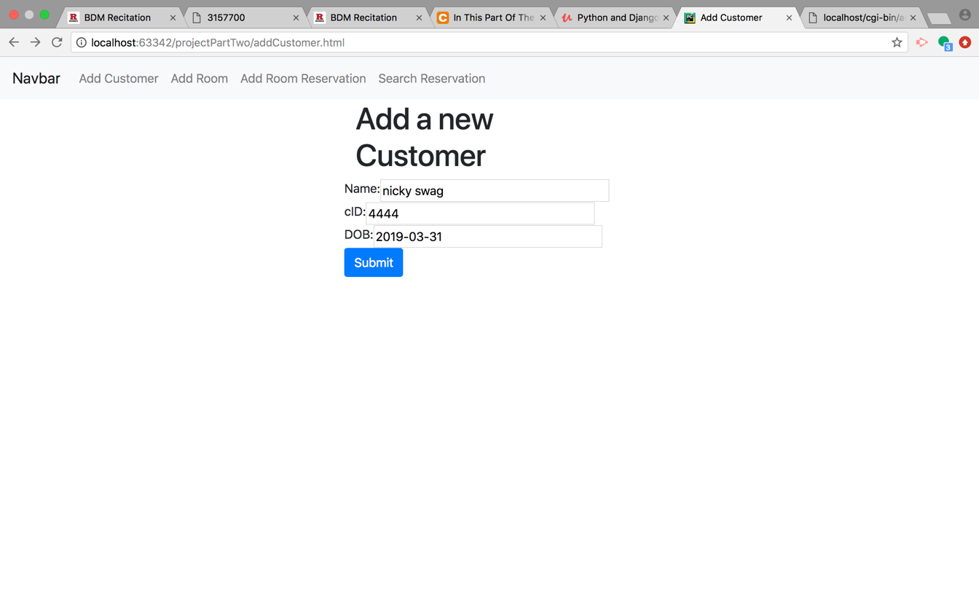

The python file adds the user with name nicky swag, cid 444, and dob 2019-03-31. It then returns the resulting relation in tabular form, and you can see that nicky swag is now the newest customer in the primaryCustomer table.

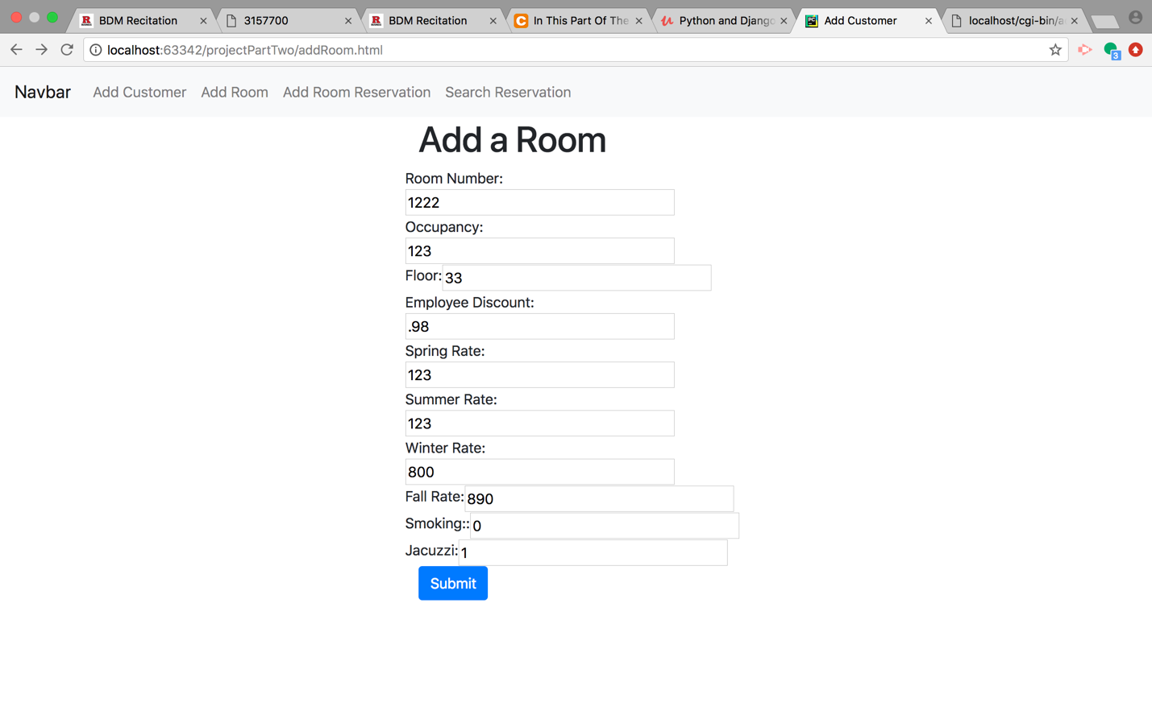

The python file takes the info from the html file and creates a new room in the room table. It then prints the room table and you can see the newest room (with room number 1222) is on the end.



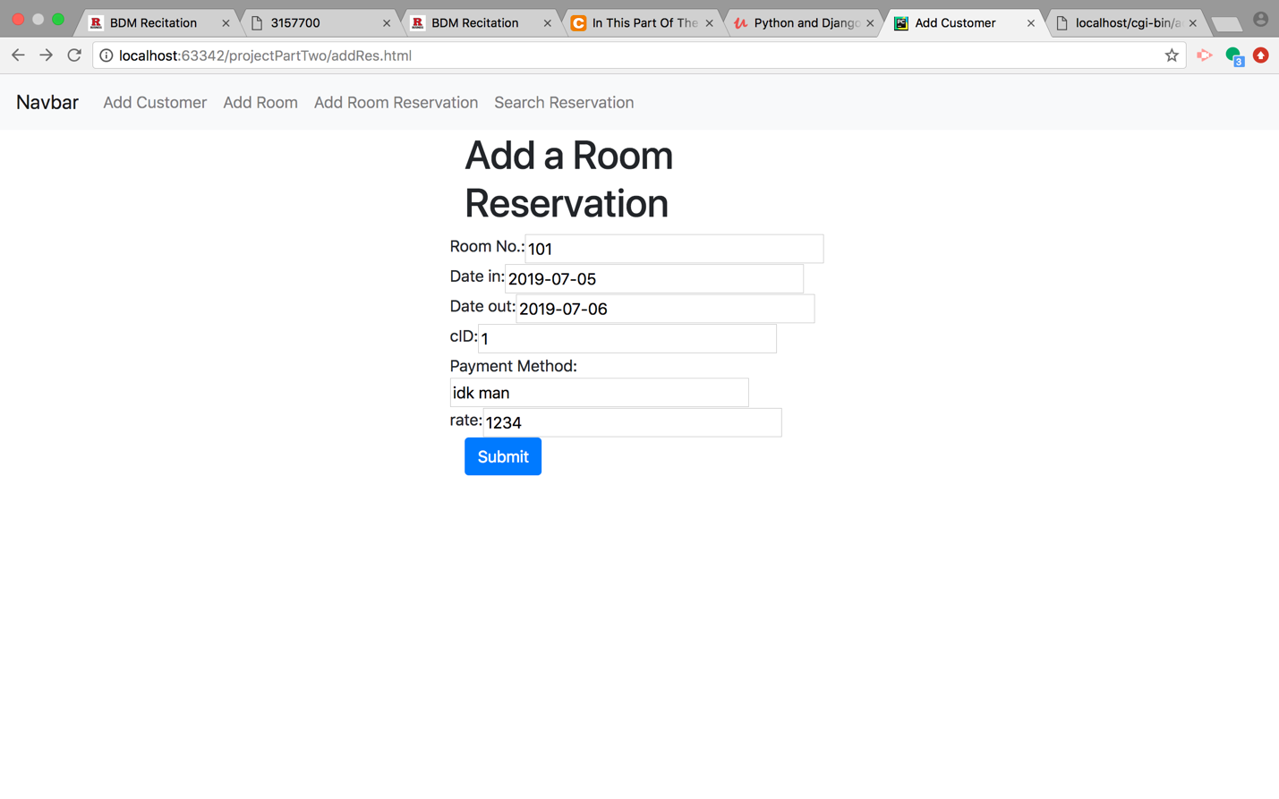

The python file takes all of the information from the html file and creates a new reservation then prints the reservation table. As you can see on the second line of the printed data, there is a new reservation with room Number 101 and payment method of ‘idk man’

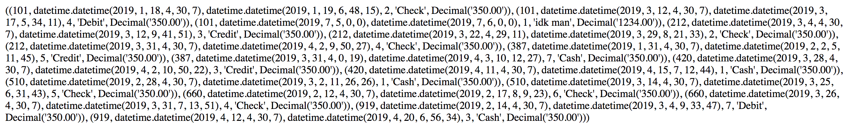

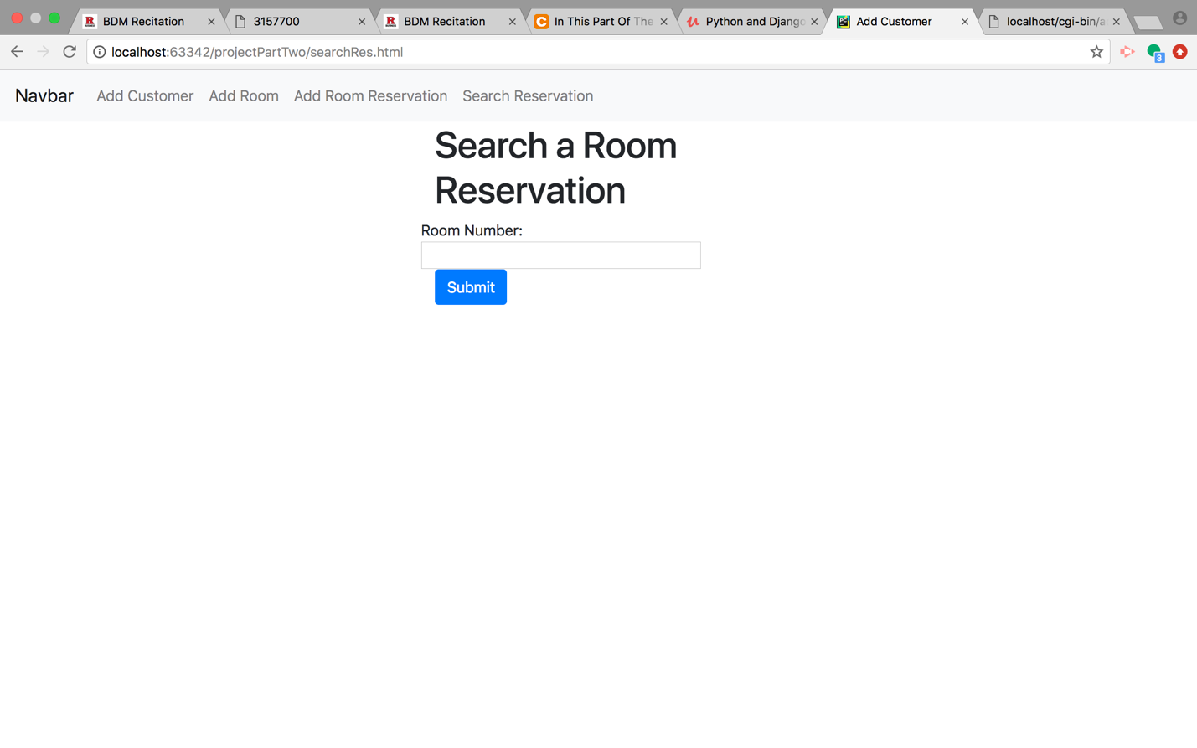

The python file takes the string from the textbox and runs an sql query where it searches the “books” table WHERE roomNumber = that value from the textbox. When we type 101 and hit submit we get the two reservation entries with roomNumber 101.

